**Lab 1 (Day-7)**

**Database Creation:**

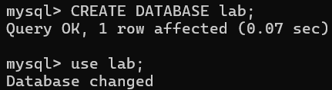

**1.Write an SQL query to create a database named StudentDB.**

**Table Creation & Constraints:**

**Create a table Students with the following columns:**

**StudentID (Integer, Primary Key)**

**Name (VARCHAR, Not Null)**

**Age (Integer)**

**Department (VARCHAR)**

**Insertion of Data:**

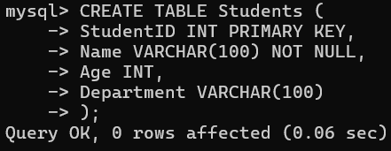

**2.Insert three records into the Students table with sample data.**

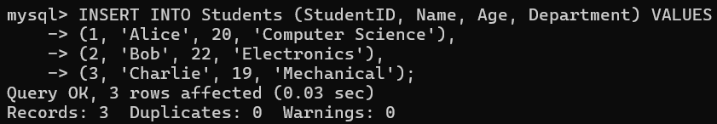

**3.Updation of Data:**

**Update the Age of a student whose StudentID is 2 to 21.**

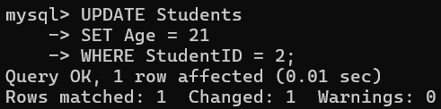

**4.Alteration of Table:**

**Add a new column Email (VARCHAR) to the Students table.**

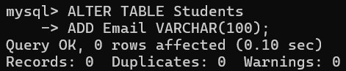

**5.Deletion of Rows:**

**Delete a student record where StudentID is 3.**

**ORDER BY and GROUP BY Clause Questions**

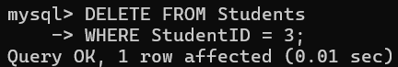

**6.ORDER BY Clause:**

**Retrieve all students from the Students table and display them in ascending order Age.**

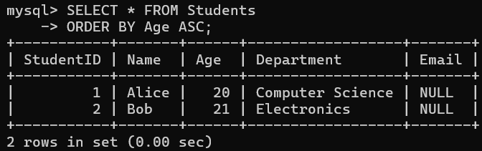

**7.GROUP BY Clause:**

**Count the number of students in each Department and display the result.**

